

Frankfurt, Germany

Guten Tag, Boston!

We felt your system was inefficient and confusing, so we installed the same system as the London office, which is much better.

London system looks like this:

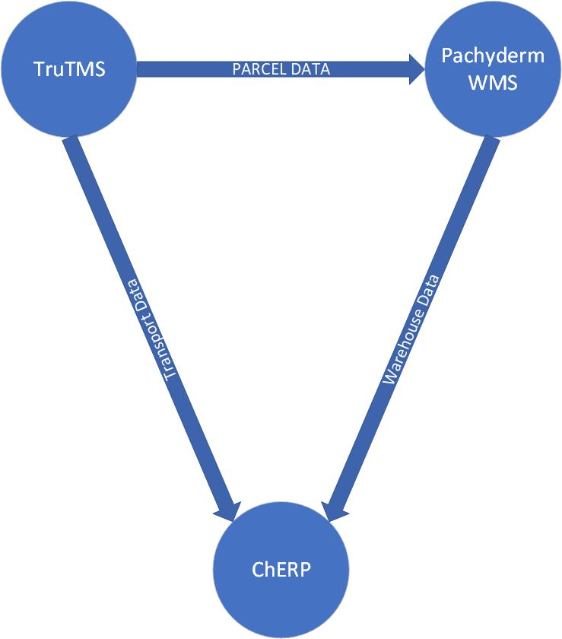

System cost, sans ChERP: € 15,885.00 EUR

Tschüss,

Hans Kleine  
Tech Systems Lead